This n That

An e-mail newsletter from Agapé Athletics Club

Editor: Marieta Bortoli 082 466 7031 10 September 2018 www.agape.org.za

E-mail: marietabortoli@gmail.com

NB

- Next league race – Clover Irene Spring Race – 29 September
- Agapé race (Jacaranda City Challenge) – 13 October. Members to assist. PLEASE DIARIZE !!!!!!
- 21.1km club championships – Chamberlains Capital Classic – 6 October
- Agapé AGM – 17 November

Editorial

Please take part in the survey on the use of water sachets at races. Refer to “In the mailbox”.

Only 5 weeks before our race day. Kindly take note that no club member is allowed to take part in the race. All members are needed to assist at the race.

Well done to Sonet Marais-Werner and Josias van der Merwe for winning the 10km club championships.

Notice Board Additions

◊ Jacaranda City Challenge
◊

Attachments

□ Criteria for runner/walker of the year

Birthday Greetings

May God look down and bless you now when your birthday’s here and keep you in His loving care each day throughout the year, and may He grant you happiness in everything you do – today, tomorrow, always, every day your whole life through!

Eloise Dirkse v Schalkwyk 10 September | Vanessa Vermaak 10 September
Ignis Claase 11 September | Kibett Strauss 11 September
Dries Strydom 12 September | Marix Venter 12 September
Mandy Atkins 21 September | Katlego Ramakobya 24 September
Hercu Bloem 25 September | Chris Burger 26 September
Fred Harding 27 September | Marie Bloem 28 September

Personalia

Welcome new and former members

Congratulations

Congratulations to the following members:

Thank you’s

Dear Marieta

I would really like to thank you and the whole Club and organising committee for a very nice club get together and lunch that we had at the same Pius church last Saturday.

Thank you very much. it was well organised, and I appreciate it very much. May you please convey my thanks to the whole board and specifically to Hennie and Marix, who are really perennial stalwarts in our club.

With my kindest regards

Gerhard Visser

In the mailbox

Use of water sachets at races. Survey done by a matric school pupil. Please take part in the survey.
https://docs.google.com/forms/d/e/1FAIpQLSfk5qxEOBH9Nt3fbzI4vhugk28g6k4lxKwE0LAIun2GqyMbwA/viewform

General
Clothing available:
Buffs @ R100
Ladies skirts @ R200
Second skins @ R220
Age tags @ R30

Please contact Marietjie if you wish to purchase some of the items:
Cell: 072 541 7268 E-mail: ventermarix9@gmail.com
The items will also be available at races, please visit our gazebo

Race reports/Upcoming race information

Race Report: Spirit of Flight (1 September 2018) – Gustav Brink
Separate start for walkers? No. Despite this, I will not allocate the normal “0” points, as the route is of such a nature that you could clearly see the other walkers several times, which means you always knew who your competition was (although I did only see the leading race walker for the first time after about 5 km) (2/5)
Separate start for 10/5? No. The 10 km and the fun run started together, with the 5 km veering off at some stage. However, it could have been quite difficult to have separate starts on this route. (0/5)
Prize money for walkers: First three overall, as well as the top two in each age category. And the prizes were the same as for the runners. Wonderful (especially as I was amongst the winners). Excellent (5/5)
Separate results for walkers: No. A real pity that there was not a separate finishing tunnel (or separate identification on the entries) for the walkers. That would have been so easy to do. (0/5)
Start: The start was on a runway, so as we’d say it was “so breed soos die Heer se genade” (as wide as the Lord’s grace). I saw several walkers at the start and even though for some reason we did not all stand together, there was no problem for the runners to come past. Lovely start, with the rising sun on our right. The start also filled from the back, which is always important. Excellent (5/5)
Route: Whenever you go south, you have to go north again. At least this is a variation on the normal “whenever you go down, you have to come up again”. Running up one runway, down the next, up the next, down the next, and so on. I know many people don’t like this format, but it does give you an opportunity to see everybody else and makes for a lot of banter between the slower runners/walkers and the faster ones. It remains one of my favourite routes. A slightly undulating route, but certainly not flat (I don’t like flat routes!) In my opinion, a fantastic route for walkers. Excellent (5/5)
Marshalling: Quite frankly, other than the lead truck (yip!), no marshals required at any stage, so this criterium does not apply in this race. (0/0)
Water points: It is a bit unfair for me to try and judge water points on a 10 km, as I don’t use them. However, from what I saw there were enough helpers, enough Coke and water, and generally good spirit (especially at one water point). Very good (4.5/5)
Access and parking: There were really more than sufficient and safe parking. If one were too complain (which I heard one or two people do, even though it did not bother me at all), it would be that the parking was some distance from the entries and the club tents. As far as I’m concerned, that just provided an early warm-up. Very good (4.5/5)
Personal experience/value for money: I arrived back the previous evening after a 4.5-hour drive from Eswatini (Swaziland), so I was not sure how my body would respond. In addition, after my previous race (the AGN walking Grand Prix) I had started training for the SA 50 km in Cape Town at the end of October, so I’ve started walking weekly distances I’ve never done before as a walker. Nevertheless, I caught Sandra Steenkamp at (I think) around 3 km and thought of walking with her, but then felt quite good and decided to simply walk my own race, concentrating on those windmill arms of mine. Most of the time I kept them at bay, but they did come back every time I wasn’t concentrating. I know the last time we were in the same 10 km race she walked around 59 minutes, so I thought I’d be OK as long as I stayed ahead of her (although I was walking my own race). I never looked at my watch, although I did take my split time at 5 km (and only looked at it when I got home). What a surprise when I finished in 56:58 – a massive PB by 2:07! Good enough for 2nd overall and 2nd in my category – but still nearly 9 minutes behind the winner, Leboeuf, who missed the SA record in the 50-54 category by a few seconds, coming in in a time of 49:16. I saw him a few times along the way and wish I could have such a gliding style as he has. Something to aspire to.
For me the race was very good value for money and I look forward to next year’s edition. Excellent (5/5)
Total: 31/45 (68.9%) That officially makes it the best mixed race to date this year based on these criteria.
==
Muller Potgieter Memorial - (1969 - 2018), 8 September 2018, 21.1 and 10 km race feedback (Elbert Loubser)
Arriving early morning, it turned out that the main field (where many previous road races had their finishing lines) of the Defence/Military Force Sports Grounds had been reserved for a …………………………………….
Dog Show!
Which implied that the finishing lanes, gazebo areas etc were moved to the adjacent rugby field (yellow circle):

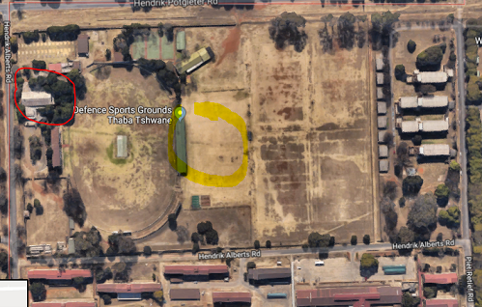

Entry tables were still in the hall (red circle), which initially meant a fair amount of walking in the dark. The START was still in a familiar spot, South West of the entry hall in Hendrik Alberts Rd. The placing of the START rather stretched the distance between the ‘remote’ microphone and the 'base station', the latter unfortunately making announcements at the START area ‘muffled’ and mostly undistinguishable.

At 06:00 a hand held 'hooter' (air horn) started the 50th addition of the Muller Potgieter Memorial Race.

The 5 kays departed at about 06:15. Although it was cold, it was nevertheless ‘warmish’ for a race in Thaba Tshwane, for this time of the year. The very serious cold front only seeping in late Saturday afternoon. Cloud cover, with an occasional sun peeping through the clouds later during the morning, kept the ambient temperature ideal for road racing conditions.

The route takes us Eastwards on Andries Pretorius Rd, South on Van Riebeeck Rd, then West on Stephanus Schoeman Rd, approaching Valhalla from the North West. A lovely downhill section on Alaric Rd and Bergen (Valhalla), with a sweep back to Alaric Rd and Kruger Rd, a revisit of Stephanus Schoeman Rd, and a right turn into Piet Retief Rd (where the 10 kay athletes leave us towards the Finish line).

For the second lap of the 21.1 kay, we headed out West on Andries Pretorius Rd then turned left into Frederick Emst Rd, re-joining Stephanus Schoeman Rd. On said second lap, the first downhill part of Alaric Rd swept to the right into a most runnable ascent of Hans Rd and Wodin Rd. Yes! That loooooong downhill section has two street names, in one straight road!

Eventually we curl back towards Alaric Rd, following the route of the first lap towards the Finish line.
A lovely medal, commemorating the 50th time this race (a historic Memorial - the oldest race in Pretoria) has been presented, awaits us as we complete the race.

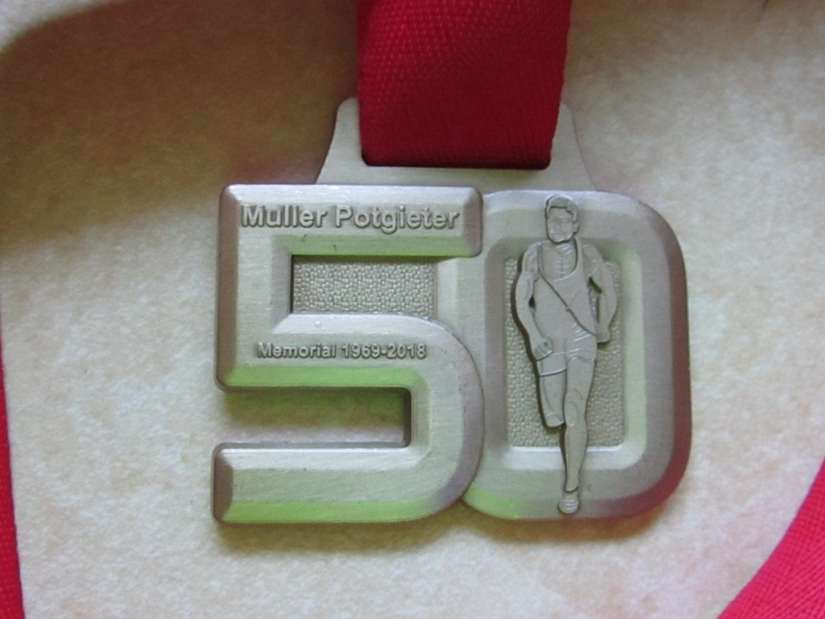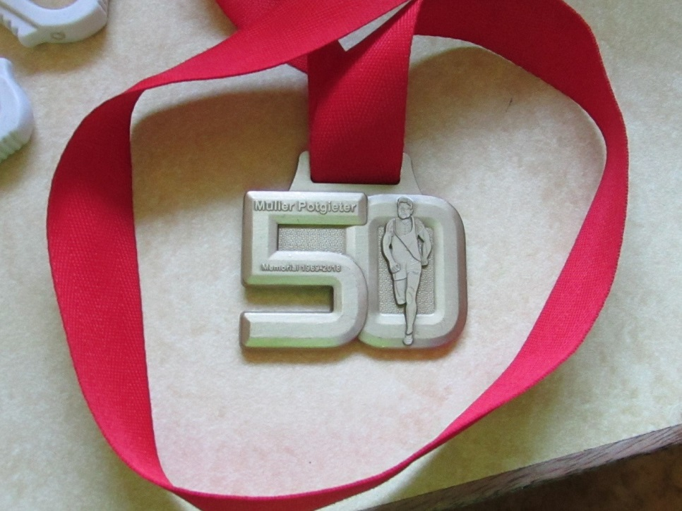

Thank you, Monument Athletics Club, (Leon Bezuidenhout and team) for their continued dedication and tenacity to keep this race ‘alive’.:-)

Race Results
Spirit of Flight (AGN) 10km race - 2018-09-01
Position | Initials | Surname | Sex | Age | Finish Time
111 | J | Van Der Merwe | M | 49 | 00:44:44
150 | S | Marais-werner | F | 44 | 00:46:44
192 | C | De Kiewit | M | 59 | 00:48:49
238 | F | Schunke | M | 60 | 00:50:49
349 | E | Strydom | F | 33 | 00:54:54
350 | B | Strydom | M | 33 | 00:54:57
362 | L | Van Wyk | F | 42 | 00:55:16
398 | K | Nurden | M | 83 | 00:56:21
417 | G | Brink | M | 51 | 00:56:58
436 | T | Oelofse | F | 44 | 00:57:19
603 | H | Venter | M | 59 | 01:03:48
612 | G | Hughes | F | 70 | 01:04:12
617 | J | Barkhuizen | M | 48 | 01:04:23
649 | C | Mouton | F | 61 | 01:05:44
689 | D | Frost | M | 62 | 01:07:21
731 | M | Venter | F | 58 | 01:09:45
794 | R | Sher | M | 75 | 01:13:42
814 | B | Boyes | F | 53 | 01:15:02
946 | M | Stadler | F | 77 | 01:30:40
1008 | E | Loubser | M | 61 | 01:51:48
Muller Potgieter (AGN) 10km race - 2018-09-08
Position | Initials | Surname | Sex | Age | Finish Time
35 | S | Marais-werner | F | 44 | 00:49:46
74 | L | Fourie | M | 73 | 00:55:36
121 | K | Nurden | M | 83 | 01:00:14
231 | J | Barkhuizen | M | 48 | 01:07:01
278 | T | Oelofse | F | 44 | 01:10:14
Muller Potgieter (AGN) 21km race - 2018-09-08
Position | Initials | Surname | Sex | Age | Finish Time
52 | K | Imrie | M | 46 | 01:41:50
109 | J | Van Der Merwe | M | 49 | 01:50:47
179 | A | Marais-werner | F | 44 | 01:58:53
191 | C | Burger | M | 53 | 01:59:51
296 | G | Brink | M | 51 | 02:08:18
505 | Z | Hattingh | F | 38 | 02:38:34
548 | E | Loubser | M | 61 | 02:57:12

League results

Training/Health snippets

Injury Prevention and Massage Therapy
Adequate recovery is essential if a runner is to benefit fully from training and prevent injuries from occurring. One way to hasten this recovery process is by using a regular massage therapy that can assist soft tissue recovery form intense exercise. After exercise, there is a prolonged elevation of muscle tone, felt as tightness, particularly during periods of adaptation to increased volume and intensity of training. This will cause impaired delivery of nutrients and oxygen to the cells and slow down removal of waste products which can contribute to abnormalities. It further limits the extensibility and shock absorbency of soft tissue, thus predisposing to soft tissue strain. Intense training also causes irritation of previously untreated lesions. This causes bulky scar tissue to develop, compromising muscle function and flexibility. This can lead to impaired training and progress to injuries.

The effect of the massage is to reduce excessive post-exercise muscle tone, increase muscle range of motion, increase circulation and nutrition to damaged tissue and deactivate trigger points. It also gives the physiotherapist time to identify any soft tissue abnormalities. It should form part of the warm-down program to maximize recovery for runners who need to exercise regularly. Massages should thus be done more often during peak training. Initially start with once a month and then more often (once a week), depending on the individual. When hill training and speed work forms part of training, massage therapy can be done more often.

Your thought for the week

In three words I can sum up everything I've learned about life: it goes on.”

Your smile for the week

The blonde walked into the store and said: ‘I’d like to buy this TV.’
The store clerk replied: ‘We don’t sell to blondes.’
The blonde got angry and went home. She dyes her hair black, puts on skate clothes and goes back to the store and says ‘I’d like to buy this TV.’
The store clerk replied: ‘We don’t sell to blondes!’
The blonde got furious and rushed to the barber, cut her hair, put on men’s clothes and went back to the store and said: ‘I’d like to buy this TV.’
The store clerk replied: ‘We don’t sell to blondes!’
The blonde stared in wonder and replied: ‘Now I’ve dyed my hair black, cut it and put on men’s clothes, how can you be so certain that I am blonde?’
The store clerk replied: ‘That’s no TV, it’s a microwave oven!’

Something to ponder over / something spiritual
The more we learn, the more we mature and grow into wiser beings. Wisdom, however, is not just collecting knowledge from here and there, but actually putting knowledge into practice.
In my journey, I’ve come to learn some lessons that completely transformed the way I live, and here I would like to share with you twelve of the most important life-changing pieces of wisdom that I’ve come to realize and which I’d advise you to keep in mind, so that they can guide you towards a more peaceful, happy, free and beautiful life.
1. What you think you become. Your mind is like a magnet attracting in your life what you constantly think about. Think of positive thoughts, and you’ll attract positivity into your life. Keep a negative mindset, and you’ll be surrounded by negativity.
2. Words are powerful. Words are a tool that helps us communicate with one another, but many of us don’t realize their tremendous power. Words can hurt or heal yourself and those around you, so always be mindful of the words you utter.
3. Everything is interdependent. Look at a tree: it is dependent on the soil, water, air and so on — without these elements, it cannot manifest. In exactly the same way, each one of us is dependent on our environment and in turn is making an impact on it. Hence, what we do to the world we do to ourselves, and vice versa.
4. Life is temporary. Whatever exists changes, and the only thing that doesn’t change is change itself. Thus, those who are attached to phenomena are bound to suffer, and only those who have learned to let go of their attachments and embrace the flow of life are able to find joy and peace in every moment.
5. Kindness can change the world. A single act of kindness can bring forth a series of acts of kindness, creating a circle of kindness that affects the entire world. Choose to be kind, even to those who are unkind to you, and the world will become a better place.
6. Work can be beautiful. In our monetary system, we are forced to submit to labour in order to earn money so that we can survive. Hence, it’s not surprising that most of us dislike or even hate work. Work, however, doesn’t necessarily have to be this way — it can actually be beautiful, if done out of the loving desire to create and contribute your gifts to the world.
7. Happiness is contagious. Happiness is, in a sense, like a virus. A person who is happy, smiling and has a positive attitude can influence those around him or her by making them happy too, without even trying to do so — just his or her presence is enough to achieve that. Once you learn to find happiness within, you won’t help but spread happiness to the world.
8. Simplicity is the key to the good life. All the great spiritual masters that have walked on earth have taught that to live well one has to live simply. To live simply means to not desire many things after you’ve fulfilled your needs, as well as to appreciate and be grateful for those things that you already have. It means to be detached from material possessions and superficial wants, and be focused on what truly matters in life.
9. Pain is there for a reason. Most people are afraid of pain and do anything to avoid it, which only results in even more pain. Pain is not an enemy but a friend who wants to teach you something important, so pay close attention to it so you can understand why it’s there and how you can overcome it.
10. Money doesn’t measure success. Although in our stupid economic system money is needed so that people can “earn a living,” money itself is not enough to bring you success, contrary to what most people have been made to believe. Success in life means to live purposefully and meaningfully, to find peace with yourself and others, and to live in a way that reflects your highest values and ideals — and the endless pursuit of acquiring more money is an obstacle to achieving all the above.
11. Friendship is important. In the modern world, especially in the West, people have become disconnected from one another. Not surprisingly, they feel lonely and alienated, being unable to relate to one another and form intimate relationships. But since it is a deep psychological need of ours to feel connected with others, we need to realize the importance of friendship and choose to spend more time with our fellow human beings.
12. You can make a difference. You might think that you are just a powerless person who doesn’t have what it takes to help create a more beautiful world, but that couldn’t be further from the truth. The reality is that every person has the power in his or her hands to contribute something of importance to the world that can help make it a better place. In fact, unless each one of us embodies the change that we wish to see in the world, no change is ever going to take place.

Cancelled Races

- Addicted to Life scheduled for 22 September
- Statue to Statue Peace Marathon scheduled for 23 September

Notice Board

Useful Links:
www.raceresults.co.za/flyers - for the latest race pamphlets
www.agn.co.za/#League for the latest league logs and the league points you earned
http://www.agn.co.za/Docs/2018/Walking/AGN%20road%20walking%20stds%20ref%20685.pdf
AGN 2017 RW qualifying standards and selection criteria
www.runawaysport.co.za Run-A-Way Sport’s web site
www.verticalhorison.co.za Trail Running www.trailseries.co.za Trail Running
http://www.mastersathletics.net/Age-Graded-Calculator.2595.0.html Age Graded Calculator
http://www.sportsinjuryclinic.net/symptom-checker By clicking where it hurts then ticking which symptoms most apply to you we can give you an indication of what injuries may apply.

Wednesday 12 September Lester Mills Memorial Night Race 10/5km
Race Organisers: Tuks Athletics Club
Venue: Tuks, Hillcrest Sports Campus
GPS: S 25.7454538 E 28.24718

 | 10 km | 5 km
Entry fees | R 80 | R 50
60 - 69 | ½ Price – race day only
70+ / Blind runners | Free – race day only
Start time | 18h30
Time Limit | 01:30

Route is not suitable for wheelchairs

No pets
No iPods or listening devices are allowed

Pre-entries at: Run-Away-Sport; Sweat Shop Southdowns

Saturday 15 September Brooklyn Road Race 21.1/10/5 km
Race Organisers: Pretoria Marathon CLub
Venue: c/o Veale & Bronkhorst Streets, Brooklyn
GPS: X -28.235 Y-25.772

 | 21.1 km | 10 km | 5 km
Entry fee | R 100 | R 80 | R 40
Entry fee 70+ / blind runners / wheelchairs | Free - race day only
Start Time | 06:00 |  | 06:10
Cut-off | ??

1st 100 on line entries receive a free parking ticket

No pets

No iPods or listening devices are allowed

Baby strollers welcome on 5km

Pre-entries at: Run-A-way Sport; Sweatshop Southdowns, Dunkeld, Fourways Crossing; Wellness Warehouse

www.enteronline.co.za

Wednesday 19 September TUT Health & Wellness Night Race 10/5km
Race Organisers: TUT Athletics Club
Venue: Tshwane University of Technology, Pretoria

 | 10 km | 5 km
Entry fees | R 70 | R 30
Start time | 18h05 | 18h10
Time Limit | 03:00

Route is not suitable for wheelchairs

No pets

No iPods or listening devices are allowed

Pre-entries at: Run-Away-Sport; Sweat Shop Southdowns; TUT Athletics Office

Monday 24 September Bophelong Half Marathon 21.1/10/5 km
Race Organisers: Bophelong Athletics Club
Venue: Bophelong Community Centre, Molepo St, Mamelodi East
GPS: S 25.7168 E 28.3769

 | 21.1 km | 10 km | 5 km
Entry fee | R 90 | R 70 | R 50
Entry fee 60 – 69 / Jardine Joggers | R 50 | R 50
Entry fee 70 | Free
Start Time | 06:00 |  | 06:15
Cut-off | 03:00

No wheelchairs

No pets

No iPods or listening devices are allowed

Pre-entries at: Run-A-way Sport; Sweatshop Southdowns; Tshwane Running Shop

www.enrytime.com

Saturday 13 October Jacaranda City Challenge 42.2/21.1/10/5 km
Race Organisers: Agapé Athletics Club & Sportsvendo
Venue: Pretoria Rugby Club, Totius Street, Groenkloof (+/- 700m from old venue)

 | 42.2km | 21.1km |  | 10 km | 5 km
Pre-entry fee (until 5 October) or when entry capacity reached | R 190 | R 110 |  | R 90 | R 60
Entry fees 60 – 79 | R 100 | R 60 |  | R 50
Late entry fees (11/13 October) | Closed | Closed | R 110
Late entry fees 60 - 79 | Closed | Closed | R 60
Jardine Joggers / 80+ athletes | Free
Event t-shirts | R 80
Start Time | 05:45 |  |  | 06:15 | 06:30
Time Limit | 05h:30 | 03h00 | 2h00

No completed tear-off strip – no results

Come early – start line is a 10-minute walk from venue

Pre-entries: Run-A-Way Sports; Sweatshop Dunkeld, Bedford & Southdowns; Sportmans Warehouse Atterbury value Mart, Centurion Value World & Kolonnade Retail Park; Brooks Gym 291 Main St. Brooklyn

Enter on line: www.timeme.co.za

2018 AGN LEAGUE FIXTURE LIST
EVENT | DISTANCE | DATE | LEAGUE
 |  |  | RR | RW
Clover Irene Spring Race | 21.1/10 km | 29/09 | X | X
CSIR Road Race | 21.1/10 km | 20/10 | X | X
Tom Jenkins | 21.1/10 km | 17/11 | X | X

Masters Athletics Fixture list

Local meetings
20 October 2018 SWD Oudtshoorn
10 November 2018 Free State Bloemfontein

South African Championships
3/4 May 2019 Oudtshoorn

Africa Champs
December 2018 Africa Championships Tunisia

International Championships
4-16 September 2018 WMA Champs Malaga, Spain
24-30 March 2019 WMA Indoor Torun, Poland
28/9-6/10 2019 30th Summer universiade Naples, Italy
20/7/2020 – 1/8/2020 World Masters athletics Champs Toronto, Canada

Time Trials:

Centurion - Wednesdays at 17:30
Lewende Woord Centurion
Contact Marinda 654 5800 (h) / 082 720 9017

Rietondale - Thursdays 17:30
North Street, Rietondale (Rietondale Park in the street before the Crawford Stadium)
Contact Hennie Venter 082 676 6792

Zita Park - Tuesdays at 17:30
Zita Street, Zita Park, Garsfontein
Contact Hennie Venter – 082 676 6792 Marietjie Venter – 072 541 7268

Gazebo Enquiries

Hennie Venter – 082 676 6792 Marietjie Venter – 072 541 7268

Intercessor:



Fred Harding 076 777 7786

Agapé Executive 2017/2018

Name | Position | Telephone number | E-mail address
Marieta Bortoli | Chairperson & editor | 012 331 2089  082 466 7031 | marietabortoli@gmail.com
Hennie Venter | Registrar, club captain & Vice-chairperson | 082 676 6792 | henniev@seng.co.za  join@agape.org.za
Marilett Jenkins | Secretary | 082 837 2142 | marilett.jenkins@mervitzmalan.co.za
André Breytenbach | Treasurer | 083 566 1090 | andreb@geoscience.org.za
De Wet de Beer | PRO | 082 373 2987 | dewet@styletechnique.co.za
 | Race organiser
Fred Harding | Intercessor | 076 777 7786 | fwhard@gmail.com
Marix Venter | Clothing co-ordinator | 072 541 7268 | Ventermarix9@gmail.com
Suzette van Staden | General activities | 083 290 6280 | suzettevs971220@gmail.com
Gustav Brink | Statistician | 083 417 8431 | gustav.brink@gmail.com

Photo corner

Agapé Executive

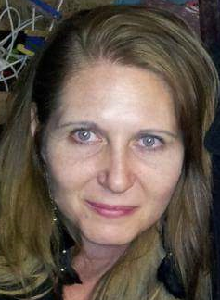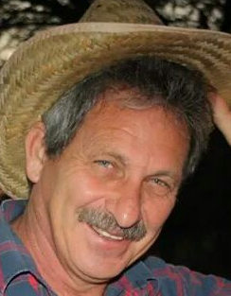
Marieta Bortoli Marilett Jenkins Hennie Venter

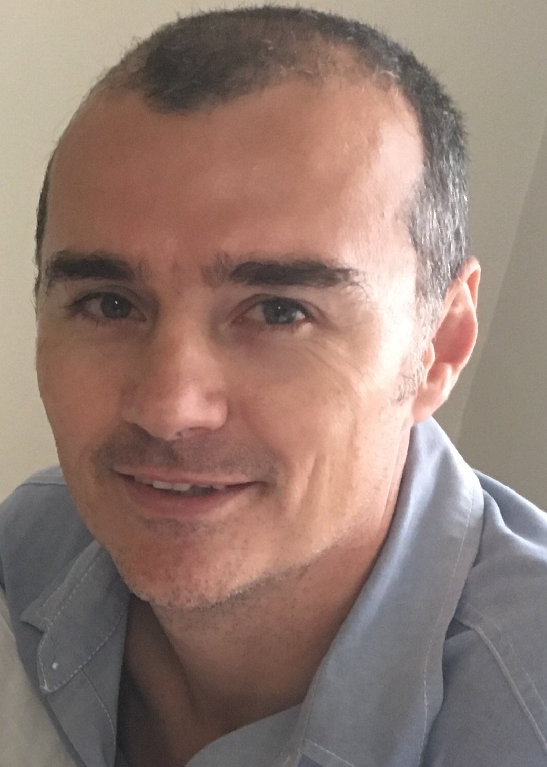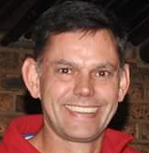
De Wet de Beer André Breytenbach Marix Venter

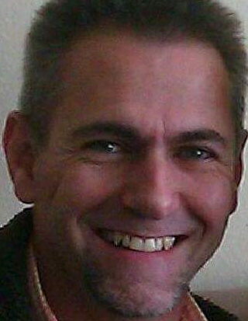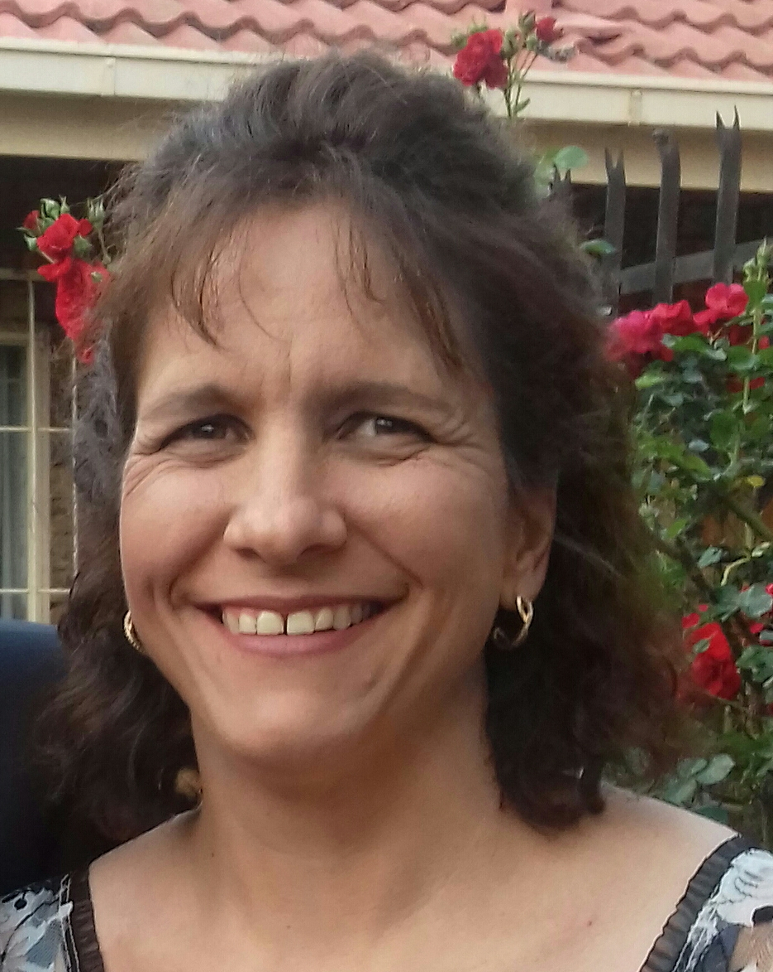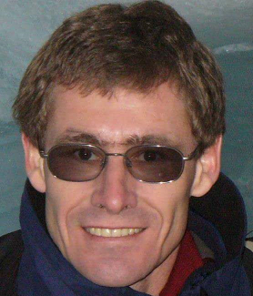
Fred Harding Suzette van Staden Gustav Brink (Ex-officio)

